INDEX_MATCH:
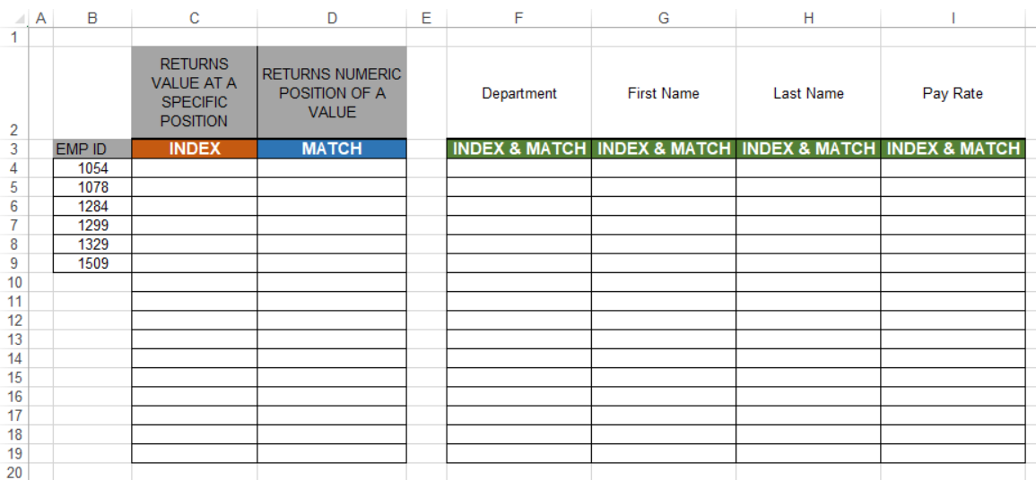

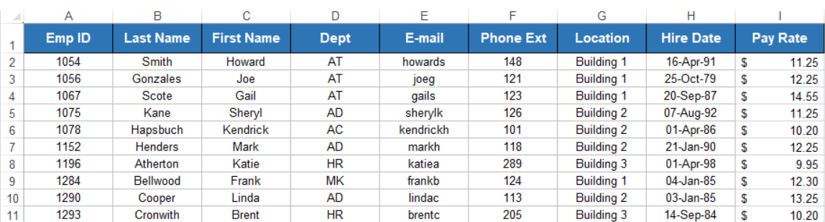

FirstName: =IFERROR(INDEX(IM_MasterList[First Name], MATCH([@[Emp ID]],IM_MasterList[Emp ID],0)),"No Matching ID")
LastName:=IFERROR(INDEX(IM_MasterList[Last Name], MATCH([@[Emp ID]],IM_MasterList[Emp ID],0)),"No Matching ID")
Department: = IFERROR(INDEX(IM_MasterList[Dept], MATCH([@[Emp ID]],IM_MasterList[Emp ID],0)),"No Matching ID")
Pay Rate =IFERROR(INDEX(IM_MasterList[Pay Rate], MATCH([@[Emp ID]],IM_MasterList[Emp ID],0)),"No Matching ID")

